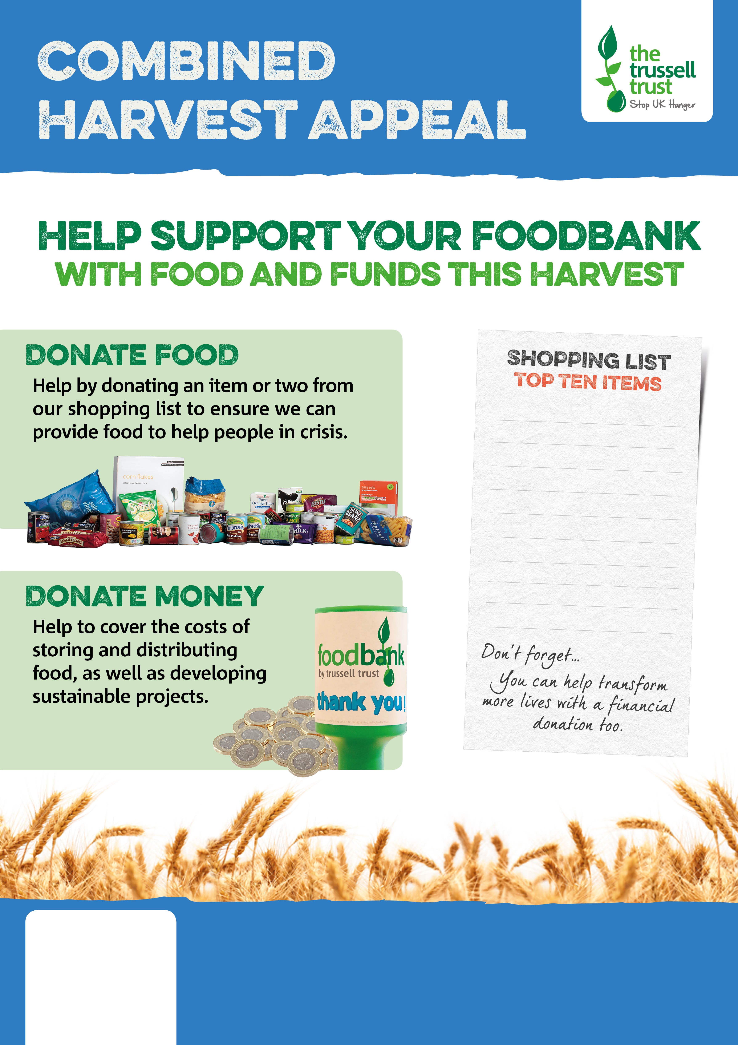

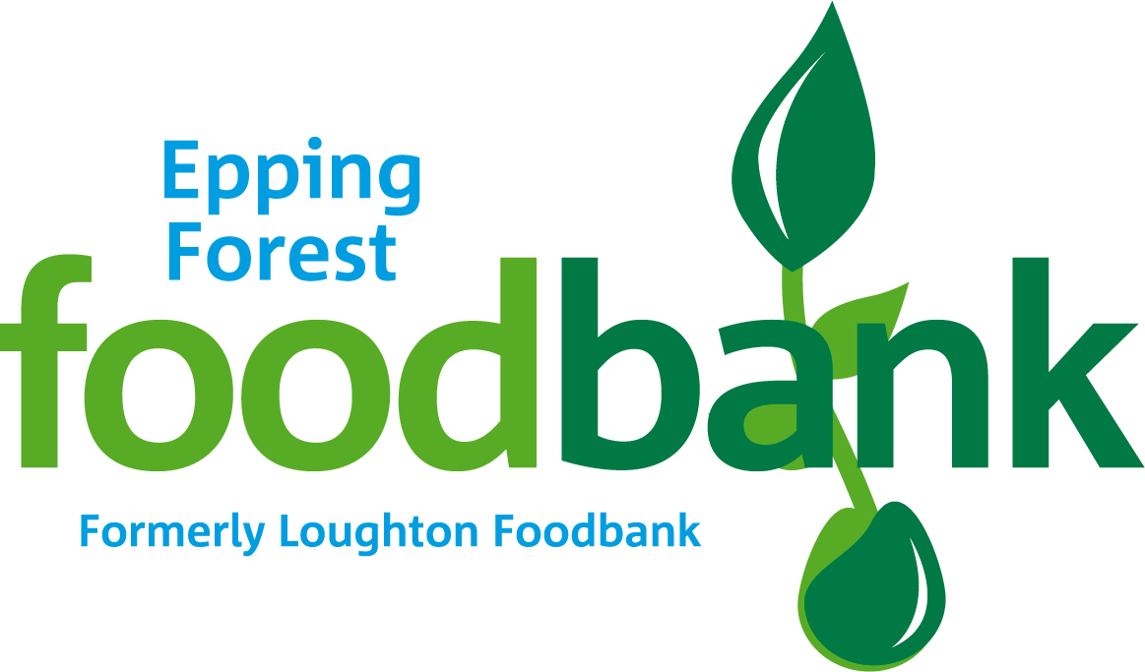

Epping Forest Foodbank

eppingforest.foodbank.org.uk

A Project of Above+Beyond and Beyond Ourselves Registered Charity in England & Wales (1165654)

Instant Mash Potato

Sponge Pudding

Rice 500g bags /Pouches

Long Life Milk

Powdered Milk

Long Life Juice

Bars of Chocolate

Coffee

Tinned Tomatoes

Rice Pudding