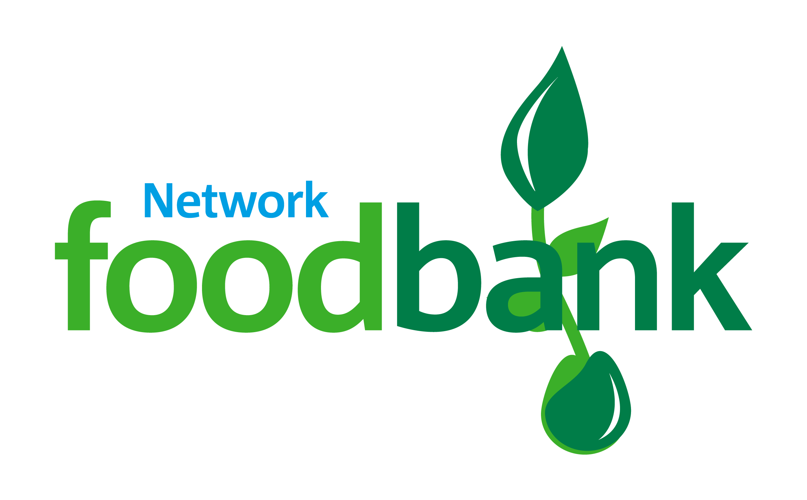

**Crackers & Biscuits**

**Christmas Chocolate**

Registered Charity in England & Wales (1182270).

Your donations will be going to a local food bank – a registered charity or charitable organisation which is part of the Trussell Trust network

**You can help this Christmas with a reverse calendar for donations!**

**Please drop in your donations at our warehouse as soon as you can. Our warehouse is open Wednesday and Friday mornings, 9:30am-12:30pm.**

**Our address is 38c Chigwell Lane, Oakwood Hill Industrial Estate, Loughton, IG10 3NY.**

**Email address:** [**info@eppingforest.foodbank.org.uk**](mailto:info@eppingforest.foodbank.org.uk) **– 0300 102 9808**

**Microwave Rice**

**Tinned Vegetables**

**Tinned Fruit**

**Hot Chocolate**

**Crackers & Biscuits**

**Christmas Pudding**

**Deodorant**

**Nappies & Wipes**

**Shower Gel**

**Shampoo**

**Pet Food**

**Diluted Squash**

**Instant Mash**

**Tinned Fish**

**Snacks**

**Tinned Spaghetti**

**Cereal**

**UHT Milk**

**Stuffing & Gravy**

**Batter Mix**

**Tinned Meat**

**Mince Pies**

**eppingforest.foodbank.org.uk**